Remote Repository

Definition
# Source: AI Source: Provided by: [Data Path: Persons Table -> ID Column: 1, Name_En Column: Motasem Essam] -> From: [ChatGPT] on [2/15/2026]
A remote repository is a version-controlled copy of your project that is stored on the internet or a server, so you can back up your work and collaborate with others.

What it does
# Source: AI Source: Provided by: [Data Path: Persons Table -> ID Column: 1, Name_En Column: Motasem Essam] -> From: [ChatGPT] on [2/15/2026]
A remote repo lets you:
- Share your code with others 👥
- Back up your project safely ☁️
- Collaborate on the same project
- Sync changes between computers
- Contribute to open-source projects

Where remote repositories are hosted
# Source: AI Source: Provided by: [Data Path: Persons Table -> ID Column: 1, Name_En Column: Motasem Essam] -> From: [ChatGPT] on [2/15/2026]
Popular platforms include:
- GitHub
- GitLab
- Bitbucket

Common remote repo actions
# Source: AI Source: Provided by: [Data Path: Persons Table -> ID Column: 1, Name_En Column: Motasem Essam] -> From: [ChatGPT] on [2/15/2026]
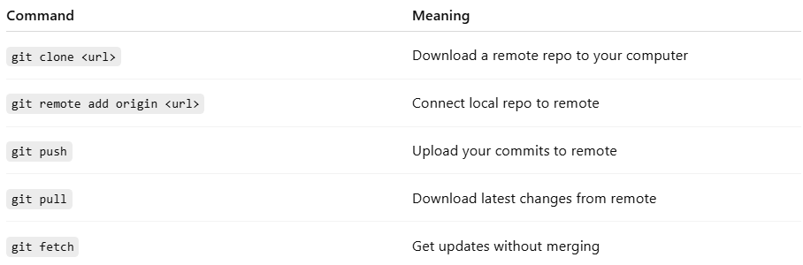
Command | Meaning
git clone <url> | Download a remote repo to your computer
git remote add origin <url> | Connect local repo to remote
git push | Upload your commits to remote
git pull | Download latest changes from remote
git fetch | Get updates without merging

Remote vs Local repository
# Source: AI Source: Provided by: [Data Path: Persons Table -> ID Column: 1, Name_En Column: Motasem Essam] -> From: [ChatGPT] on [2/15/2026]
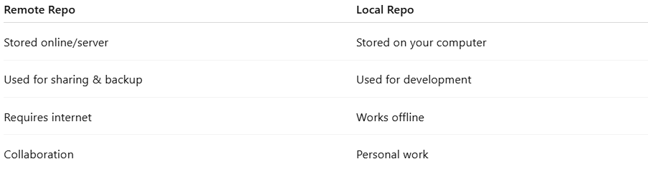
Remote Repo | Local Repo
Stored online/server | Stored on your computer
Used for sharing & backup | Used for development
Requires internet | Works offline
Collaboration | Personal work

Simple explanation
# Source: AI Source: Provided by: [Data Path: Persons Table -> ID Column: 1, Name_En Column: Motasem Essam] -> From: [ChatGPT] on [2/15/2026]
A remote repository = your project stored online so you can sync, share, and collaborate.

